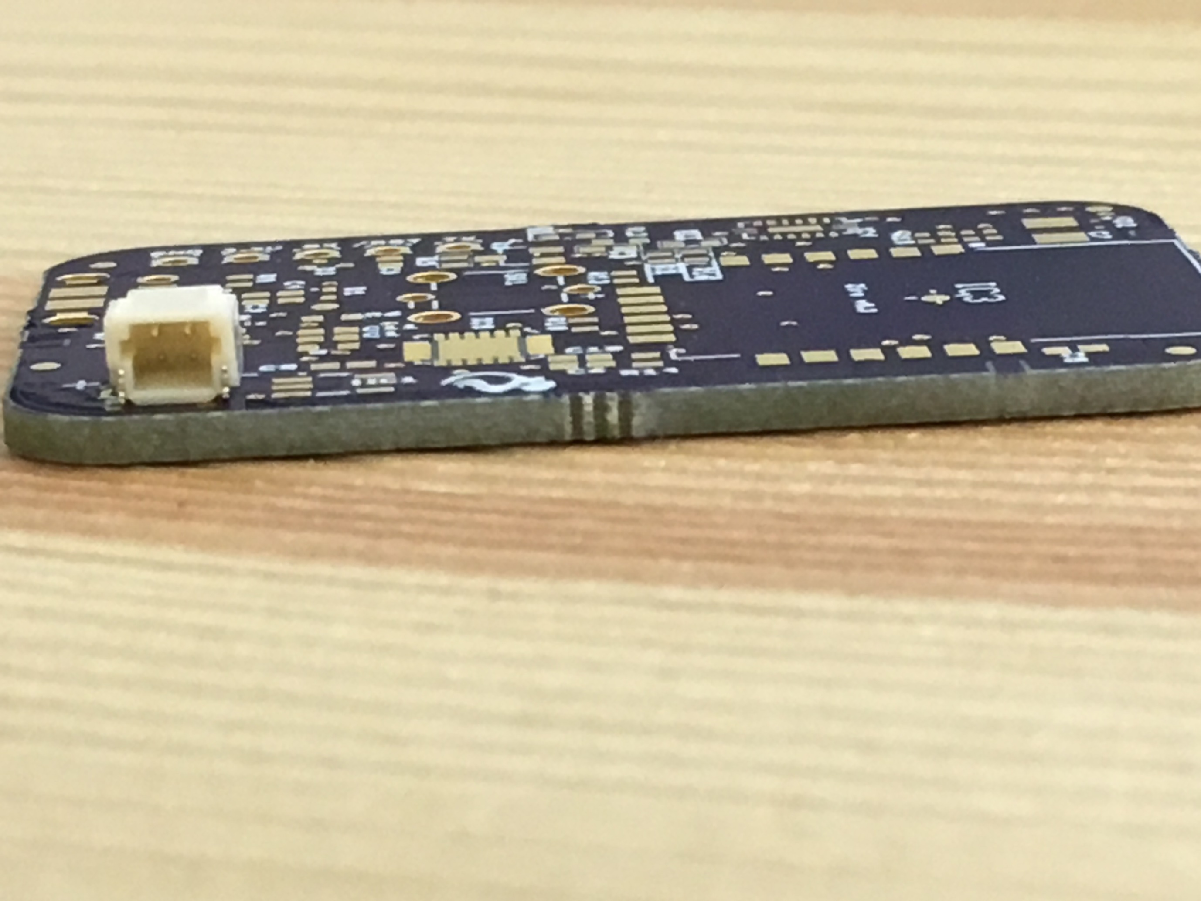

**Side View of Battery Female Connector on PCB**

**This document indicates the battery connector polarity on the PCB. Kayo Battery uses JST-SHR-02 as a male connector from the battery. Given that information, we are currently using the connector SM02B-SRSS-TB(LF)(SN)[**[**Product Link**](http://www.digikey.com/product-detail/en/jst-sales-america-inc/SM02B-SRSS-TB(LF)(SN)/455-1802-1-ND/926873)**] [**[**Datasheet Link**](http://www.jst-mfg.com/product/pdf/eng/eSH.pdf)**]. The images below show the required polarity from the battery wire terminals.**

**Kindly ensure proper polarity of battery male connector using the info below.**

**+**

**-**

**Battery Connector Polarity Indication**

**-Nikhil Jali  
22nd September 2016**

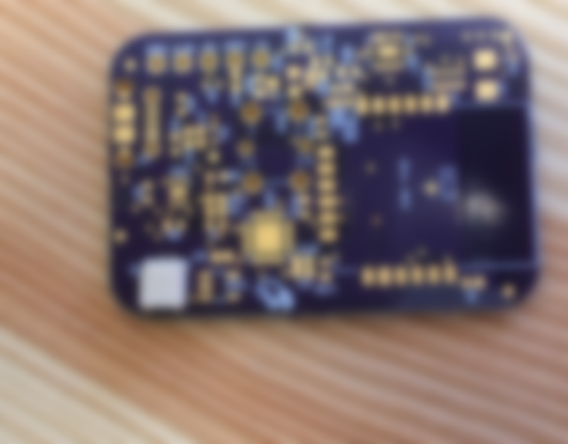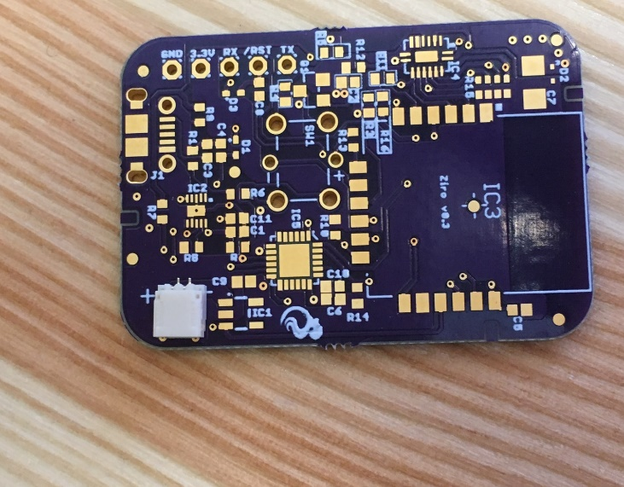

**+**

**-**

**Top View**

**Side View Enlarged**





